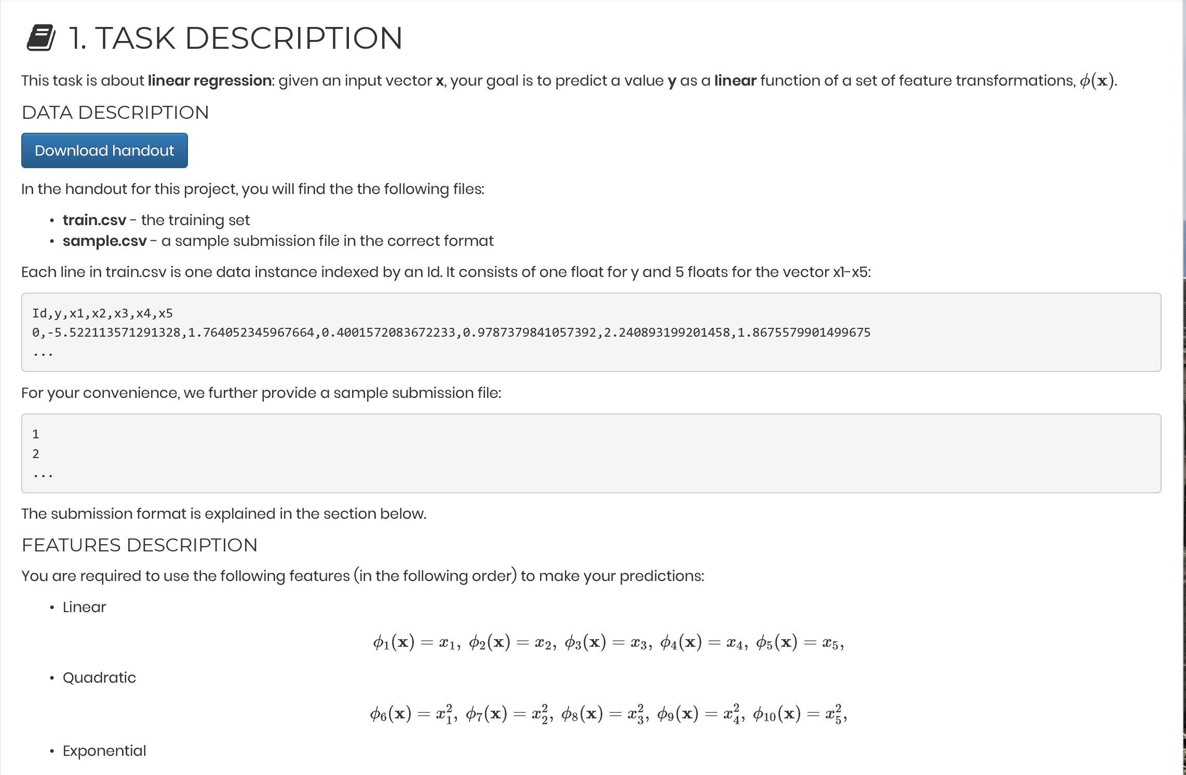

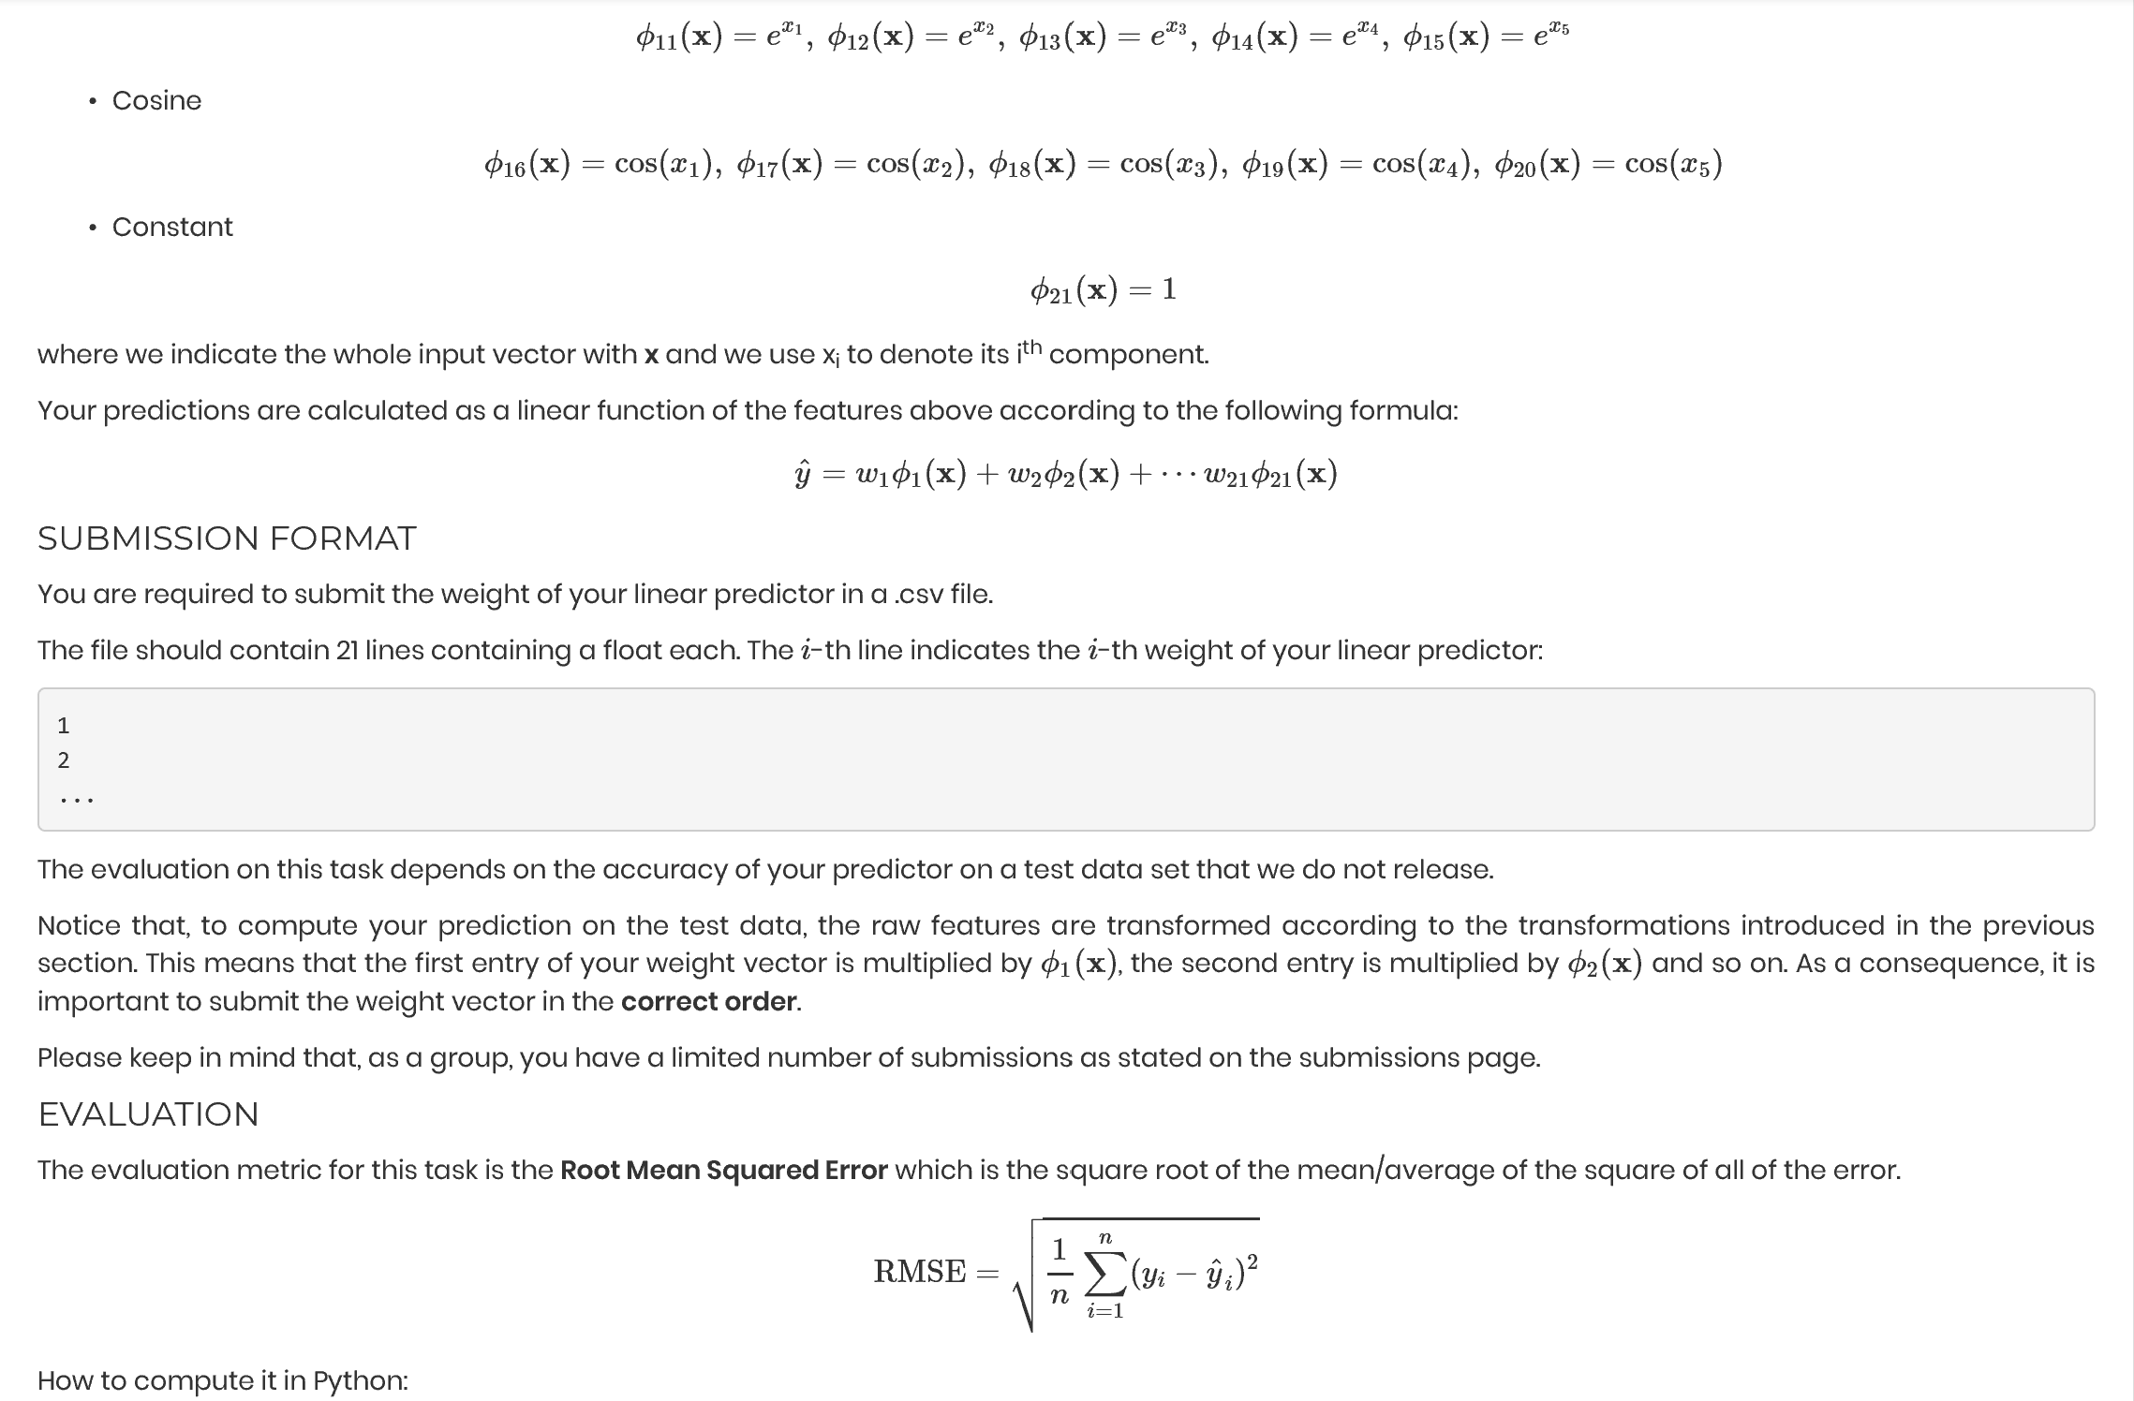

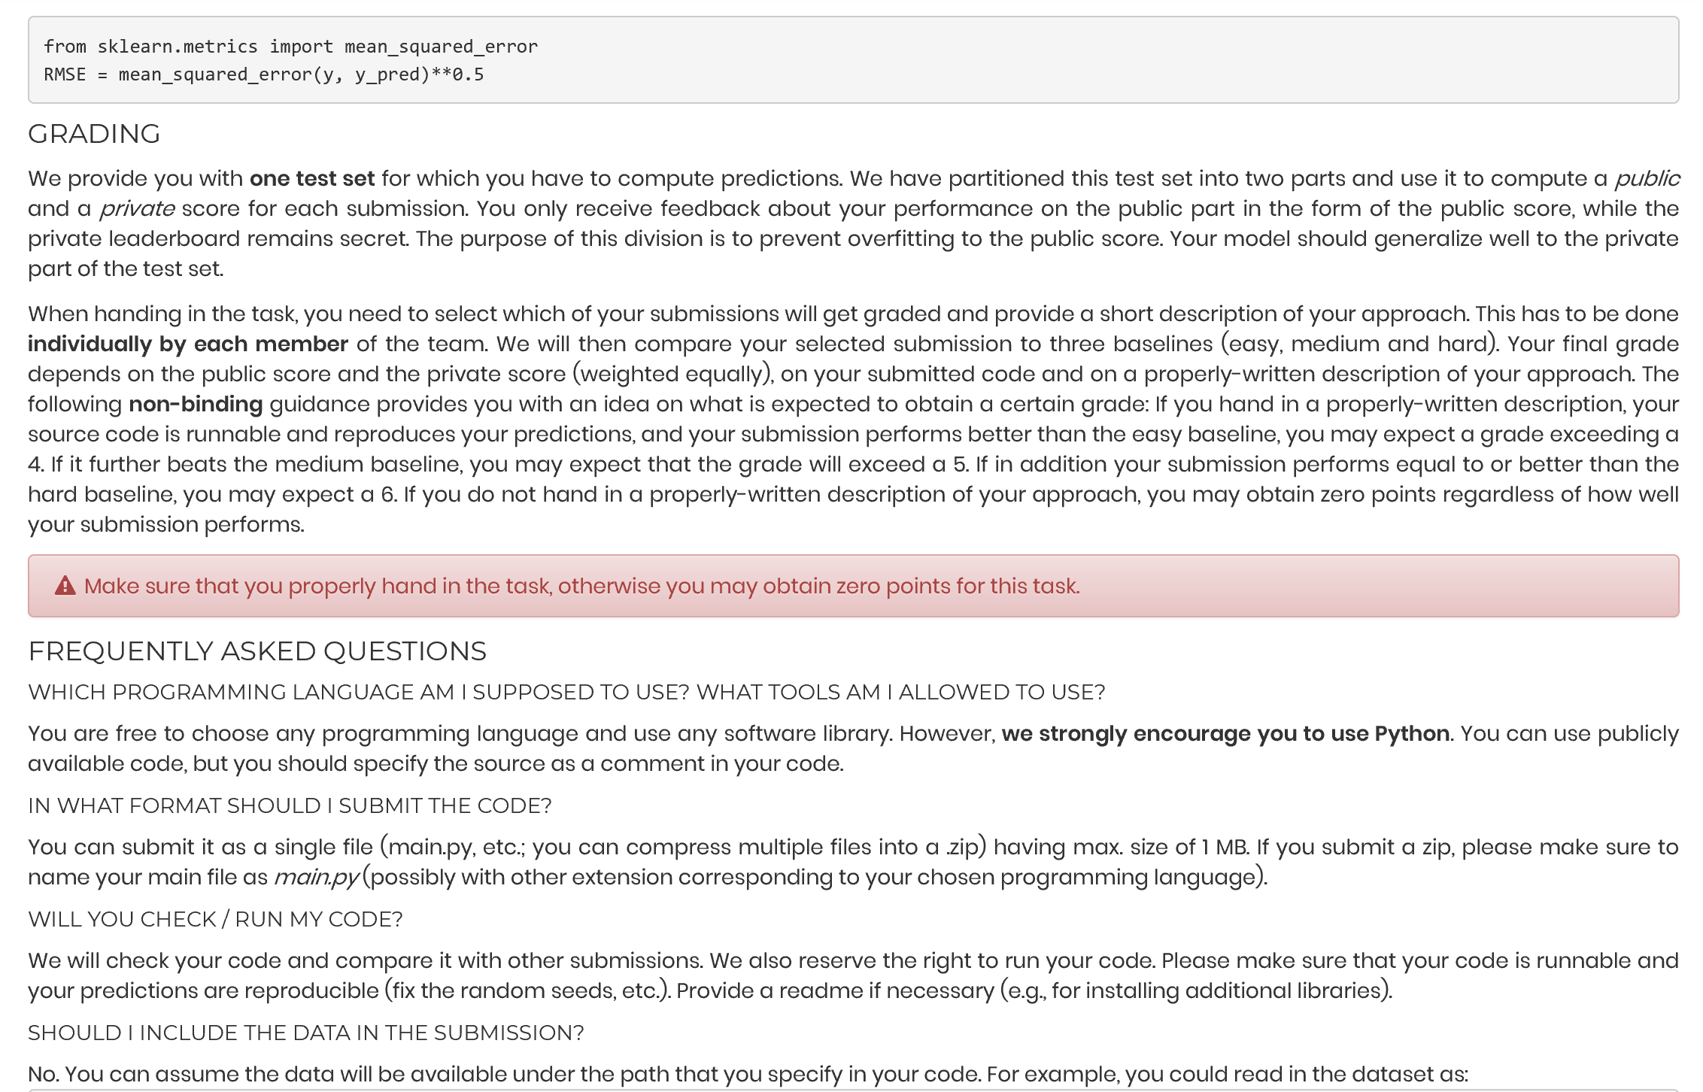

|  |  |  |
| --- | --- | --- |
|  | Hard baseline | 10.0837155033 |
|  | Medium baseline | 10.2543753597 |
|  | Easy baseline | 11.0856036978 |

After reading and dividing the training set into a y and an X part, we performed the transformation on the data as given in the task (a quadratic, an exponential and a cosine transformation for each of the initial variables). Finally, the constant was added (a column of ones). In the following, a ridge regression of y on X was executed. In order to minimize the public score, we set the penalty parameter for the weights to 1,000. This was chosen by simple trial and error. We also had to make sure that the regression function did not fit an additional intercept, as there was already one in the last column of X. This was needed to avoid perfect multicollinearity. As a first indicator, the RMSE for the training set was calculated before writing and saving the weights of the regression in a csv-file.